

GRIDTALK
Release Notes

Document Revision: 4 | 13 April, 2012
Applicable to: | GridTalk Version 4.2

Table of Contents

Table of Contents 2
Revision History 3
Text Conventions 3
1 Overview 4
1.1 Description 4
1.2 Product Information 4
2 Pre-requisites 4
2.1 Upgrade requirements 4
2.2 System Requirements 4
3 Installation Instructions 4
3.1 Full Installation 4
3.2 Upgrade Installation 4
3.3 Patch Installation 5
4 Change Notes 5
4.1 V4.2.4 – (Build 4.2.4) – 10 April 2012 5
4.1.1 Component Upgrades 5
4.1.2 Changes to Existing Functionalities 5
4.1.3 Enhancements 7
4.2 V4.2.3 – (Build 4.2.3) – 15 Nov 2010 8
4.2.1 Component Upgrades 8
4.2.2 Changes to Existing Functionalities 8
4.2.3 Enhancements 9
4.3 V4.2.2 – (Build 4.2.2) – 12 July 2010 10
4.3.1 Component Upgrades 10
4.3.2 Changes to Existing Functionalities 10
4.3.3 Enhancements 11
4.4 V4.2.1 – (Build 4.2.1) – 13 Sep 2009 12
4.4.1 Component Upgrades 12
4.4.2 Changes to Existing Functionalities 12
4.4.3 Enhancements 15
4.5 V4.2.0 – (Build 4.2.0) – 24 May 2008 20
4.5.1 Component Upgrades 20
4.5.2 Changes to Existing Functionalities 20
4.5.3 Enhancements 24
5 Known Issues 26
5.1 Functional Issues 26
5.1.1 Operational Issues 26
5.1.2 Communication Issues 26
5.1.3 Document Issues 26
5.2 Non-Functional Issues 26
6 Release Packs 27
6.1 Installation Packs 27
6.1.1 Build 4.2.1 27
6.1.2 Build 4.2.2 28
6.1.3 Build 4.2.3 29
6.1.4 Build 4.2.4 30
6.2 Upgrade Packs 30
6.2.1 Build 4.0.2 – 4.2.0 30
6.3 Patches 30

Revision History

Revision | Date | Name | Comments
1 | 23 May, 2008 | Tam Wei Xiang | Initial creation – build 4.2.0
2 | 13 Sept, 2009 | Tam Wei Xiang | Add release note for build 4.2.1
3 | 22 Sept, 2010 | Tam Wei Xiang | Add release note for build 4.2.2 Solaris, 4.2.3 Fedora
4 | 13 April, 2012 | Tam Wei Xiang | Add release note for build 4.2.4

Text Conventions

In this document the following text conventions are used:

- Text that is bold and italicized represents registered and trademarked product names or standards code names. For example: Internet Explorer, GridTalk, Microsoft Windows, RosettaNet.
- Text that is in bold represents application elements that cause the screen or database to change. This includes the names of tabs, buttons, and hyperlinks functions. For example, Administration (tab), Browse (button), Refresh (hyperlink function).
- Text that is in Title Case, upper and lower-case letters, represents screen fields.
- Text that is italicized represents specific field values.
- Text that is blue and underlined represents a script name or program provided with the release, or a defect number such as GNDB00012233.

- Text that is red and in bold represents important information that need to be taken note of.

- Text that is blue and in bold represents information that are worth taking note of.

Overview

Description
The 4.2.X series is a major revision of the 4.0.X series to improve the overall application performance.

The 4.2.X release is built based on the 4.0.2 series and 4.1.1 series which include the cumulative patch/enhancement in the existing 4.0.2. The feature we implemented in the 4.1.X is also included in the 4.2.X release. The features include the cluster ready GT, transaction monitoring (TXMR), report generation, the backend import via HTTP post etc. By default, such features are not being enabled.

Product Information
Application Server | JBoss 4.2.3
Database Engine | PostgresSQL 8.2.5-1 (Windows)
Java Run-time Engine (JRE) | 1.5.0_20 (Windows)
RosettaNet Compliance | RNIF 1.1 and RNIF 2.0

Pre-requisites

Upgrade requirements
This upgrade release notes assume GridTalk is a fresh installation.

System Requirements
Hardware | Minimum | Recommended
CPU type | Intel Dual Core | Intel Xeon or equivalent and higher
CPU speed | 2.0 GHz | 2.0 GHz or higher
RAM | 2 GB | 4 GB
Hard disk free space | 10 GB | 20 GB or higher (depends on amount of historical transactions)
Internet Connection Speed | 512 Kbps | 10 Mbps or higher

Supported OS | Windows XP (SP3), Windows Server 2008 64 bit
Supported Internet Browsers | Internet Explorer 6.0, 7.0, 8.0, Firefox 1.5 or later, Chrome 10

Installation Instructions

Full Installation
- Follow the instructions in section 6.1 for the relevant build to carry out a new installation of the release.

Upgrade Installation
Not available.

Patch Installation
Not available.

Change Notes

V4.2.4 – (Build 4.2.4) – 10 April 2012

Component Upgrades

JBoss Application Server
None

PostgresSQL Database Engine
None

Java Run-time Engine (JRE)
None

Apache Ant
The upgrade of Apache Ant library resolves the incompatibility issue running on Windows server 2008.

Library | Previous Version | Upgraded Version
Apache Ant | 1.5.1 | 1.8.2

Changes to Existing Functionalities

Bug Fixes

AS2 Bug Fix
None

RNIF Bug Fix
None

Configuration Bug Fix

#3471, #3496
Resolve the scheduled task creation issue if user choose the frequency as Weekly. The corresponding run time is also not captured properly.

Other Fix

#2115
Pro-actively detect any scheduled task that is stopped unexpectedly and resume it.

#2340
Resolve the Gridmapper map incompatibility issue in GT4.X.

#2594, #3204
Resolve the receiveDocumentQueue built up issue

#2591
Resolve the case where the JBOSS JMX console authorization (http://localhost:8080/jmx-console) mechanism can be by passed.

#3349
Resolve the malfunction of the Web services interface if we run GridTalk as Window services.

Configuration Changes
None

General Operational Changes

#3352
Updated 3rd party executable program that can run on both Windows and Windows 64 bit platform.

#3504
Enforce the use of JRE that is bundled with GridTalk application within backend sender/backend listener batch script. Previously user has to explicitly define the location of the JRE in those batch scripts.

CALL %GRIDTALK_HOME%\bin\setenv.bat
%JAVA_HOME%\bin\java -jar sender.jar %PARAM1% %PARAM2%

The invocation to the setenv.bat will initialize the %JAVA_HOME% environment variable and point to the JRE come with GridTalk application.

User Interface Changes
None

Others Changes

#3475
Increases the data source max allow connection in gtas-ds.xml and jms-ds.xml. The PostgreSQL database max allows connection is also increased.

Enhancements

Mapping Rule Changes

#3193 Derive the file extension from Mapping Rule Configuration
Currently, the default output file extension of the MapForce map is “.xml”. The configuration has been enhanced that the user can specify the output file extension in the field “Target Doc File Type”.

V4.2.3 – (Build 4.2.3) – 15 Nov 2010

Component Upgrades

JBoss Application Server
The JBoss Application Server has been upgraded from v4.2.2 to v4.2.3. This upgrade fixed the JMS Redelivered flag issues (https://jira.jboss.org/browse/JBAS-4870) which is needed for GT Clustering support.

PostgresSQL Database Engine
PostgresDB: postgresql-8.4.4-1-linux.bin x86 (Linux)
PostgreSQL JDBC Driver: postgresql-8.4-701.jdbc3.jar

Java Run-time Engine (JRE)
None

Apache Axis
The upgrade of Apache Axis library will enable the application to support SOAP 1.2, WS-Security.

Library | Previous Version | Upgraded Version
Apache Axis | 1.1 | Axis2 v1.3

Changes to Existing Functionalities

Bug Fixes

AS2 Issue

RNIF Issue

General Operational Issues
None

User Interface

Others
None

Enhancements

Optional RNIF Service Header

Support the configuration for a particular Business Entity and a particular Trading Partner
Currently, the customization of the RNIF service header is based on the Process Def Name. The user can not re-use the same Process Def for different Trading Partner if they want to customize the service header element.

This enhancement allows the user to configure the customization on the Service Header based on a particular Business entity or a particular Trading Partner without the need to re-create a new Process Def.

Follow the guide in the sample.opts under $GRIDTALK_HOME/data/GNapps/gtas/data/sys/rnifopts to configure the custom service header.

Exchange Document via Web service
Trading partner is now able to retrieve the document from the application via the service MessageRetrieveService. This service acts similar to a FTP server from client point of view. Refer to admin guide section 11.3 Front Web Services Integration for detail.

V4.2.2 – (Build 4.2.2) – 12 July 2010

Component Upgrades

JBoss Application Server
None

PostgresSQL Database Engine
None

Java Run-time Engine (JRE)
None

Changes to Existing Functionalities

Bug Fixes

AS2 Issue

RNIF Issue

General Operational Issues

Backend Receiver SystemUtil Class Not Found
The Backend Receiver thrown “java.lang.NoClassDefFoundError: com/gridnode/pdip /framework/util/SystemUtil” when processing the file that is delivered from GT.

The problem is fixed.

User Interface

Others

#1553
RMI call from external client to stateful session bean deployed in GT is prevented.

The java option JAVA_OPTS="$JAVA_OPTS -Djboss.remoting.pre_2_0_compatible=true" has been disabled in the “run.sh” under $GRIDTALK_HOME/jboss-4.2.2.GA/bin.

The problem is fixed.

Enhancements

Mapping Rule Changes

Added in support for MapForce Mapping
Currently, GT only support for GridMapper rule file. This enhancement includes the support for MapForce mapping rule file (the jar file).

To create the MapForce mapping rule file,
- Create a Mapping File with type “Java Binary” under the “Mapping Files” section.

To configure the Mapping Rules with MapForce Mapping File
- Configure the Mapping Rule as type either “Convert” or “Transform”.
- Select the Mapping File with type “Java Binary”
- Specify the Mapping Class

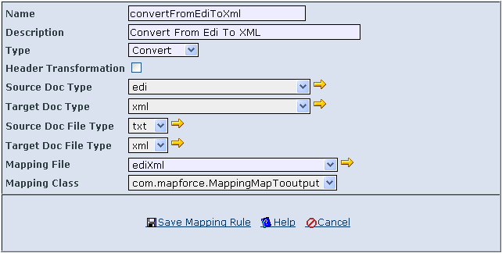

V4.2.1 – (Build 4.2.1) – 13 Sep 2009

Component Upgrades

Java Run-time Engine (JRE)
The JRE version has been upgraded from v1.5.0_14 to v1.5.0_20. This upgrade improves the performance of the core executing engine of the software.

Certificate and Security APIs
The API for Certificate and Security has been changed from RSA J-SAFE/B-SAFE to BouncyCastle. Refer to ticket # 560.

XML APIs
The following XML APIs are upgraded to support the XSLT 2.0.

API | Previous Version | Upgraded Version
GN-XML | 1.1.1 | 1.1.2
Saxon | 6.5.5 | B-9.1

Changes to Existing Functionalities

Bug Fixes

RNIF Issues

#842
The digest is wrongly computed given the Outgoing message that is delivered to TP. The issue is due to we computed the digest on the following message which including the additional header "Message-ID:"
Message-ID: <17518801.341249942960331.JavaMail.weixiang@SG017ED-WX>
MIME-Version: 1.0
Content-Type: multipart/related; type="application/xml";
boundary="----=_Part_102_9751338.1249942960331"
------=_Part_102_9751338.1249942960331
Content-Type: application/xml
Content-Transfer-Encoding: 7bit
Content-ID: <10897206.1249942960331.GridNode.weixiang@SG017ED-WX>
Content-Location: RN-Preamble
The expected message content for computing the digest that is indicated in RNIF2.0 is as followed. We need to compute the digest starting from the header "Content-Type: multipart/related" onward till the payload
Content-Type: multipart/related; type="application/xml";
boundary="----=_Part_64_16558596.1249582295227"
------=_Part_64_16558596.1249582295227
Content-Type: application/xml
Content-Transfer-Encoding: 7bit
Content-ID: <33422464.1249582295227.GridNode.weixiang@SG01732-REEZAED>
Content-Location: RN-Preamble
This problem is fixed.

#841
The validation of Rosettanet non repudiation of receipt is ignored even though user has enabled it under Process Def configuration page.

This problem is fixed.

AS2 Issues

#840
The digest algo we use in the MDN is not followed the same algorithm Sender has specified in their Outgoing msg. The one we always use in generating the message digest is SHA1, it is possible sender will use MD5 instead.

This problem is fixed.

#472
The document transaction status in MDN failed to be updated into the Outbound GridDocument (it remains as ‘Ongoing’) and it confuse the user that the AS2 document they sent out is not acknowledged by their trading partner.

This problem is fixed.

Configuration Issues

Trac 148
Currently, the user is not allowed to select the grid document field “Date Time Created” as part of the document search query criteria.

This problem is fixed by adding in the “Date Time Created” as one of the search query criteria.

General Operational Issues

#556
When we configure the GT running as window services, all the output will be appended to "stdout.log". The file size of the log will be growing to more than 15 GB if the GT is continuously running for few months without any restart.

This problem is resolved by disabling the logging to the “stdout.log” as the same log message will be logged under “server.log” as well.

Invalid choice of password
If the user specify the new password less than 6 chars, the application will prompt the user indicating the invalid choice of password. Such error message is not descriptive and user does not know how to act on it.

This problem is fixed by output a more descriptive error message when user entering a password less than 6 chars. In addition to that, When the admin create the account for a user, the password length entered by the admin is required at least 6 chars.

Trac 55
The backend import of document from sender.bat and senderlite.bat can cause the authentication module failed (stack overflow exception) to function properly and reject the login from user as well as sender/senderlite. This is due to the accumulation of the JAAS Policy object whenever there is a login attempt either from User or from Sender/Senderlite.

This problem is fixed by removing the accumulation of the JAAS Policy object.

Trac 31
If the user accidentally removed the business entity from the application, the user can not recreate the same BE ID.

This problem is fixed by allowing the user to re-activate the deleted business entity.

Others

#473
Currently, the length of the Recipient Partner ID and Sender Partner ID field of the GridDocument table is not same as the length of the Partner ID defined in the Partner table. This cause the operation related to the GridDocument for example Archival and Document Search malfunction.

Enhancements

Archival Changes

Schedule Archival
A schedule archive feature has been added in to facilitate the routine work on performing the transaction data archival.

Previously user is only allowed to specify an ad-hoc archive. With this enhancement, user can specify one or more archive task in a recurrence basic.

The configuration of the schedule archival consists of two major task includes the creation of the schedule archive task and the creation of the schedule task.

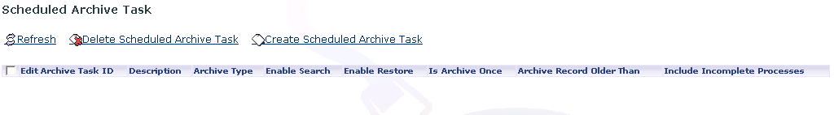
Creation of Scheduled Archive Task

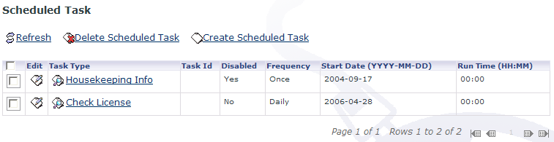
Creation of Scheduled Task

Refer to GidTalk 4.2 Administration Guide, Chapter 13.3 for more detail on configure the schedule archival.

Mapping Rule

XSLT2.0
The mapping engine has been upgraded to support the latest XSLT2.0. This allows the user to make use of the function that is newly introduced in XSLT2.0.

Backend Import Changes

Password Masking
Instead of storing the user password in plain text format within various backend import configuration file for example senderlite.bat and sender.ini, this enhancement will enforce the storing of the password in masked form.

To mask the account password,
- Go to %GRIDTALK_HOME%\bin\admin via a command prompt
- Execute the batch script within the command prompt. The ‘password’ is the password of the admin account.

maskedPass.bat password

- Copy the output, and replace the password section of senderlite, sender.ini.

The following show the sample sender.ini with the masked password.
<?xml version="1.0" encoding="UTF-8"?>
<Property key="PORT_NAME">PORT0001</Property>
<!--Property key="HOST_DIR">C:\GTQA\GridTalk\backend\sender\PO</Property-->
<Property key="GT_IP">localhost</Property>
<Property key="GT_PORT_NUMBER">6763</Property>
<Property key="USER_NAME">admin</Property>
<Property key="PASSWORD">V1ZkU2RHRlhORDA9</Property>
<Property key="BIZ_ENT_ID">DEF</Property>
<Property key="SMTP">192.168.213.251</Property>
<Property key="EMAIL">admin@gridnode.com</Property>
<Property key="LOCKFILE">lock</Property>
<Property key="TIMEOUT">5</Property>
<!--Property key="COMMAND_FILE">preprocess.sh %FILENAME %FILENAME_tmp tmp_%FILENAME</Property-->
<!--Property key="ATTACHMENT_DIR">c:\orders\00001000\attachments</Property-->
</Init>

Document Management Changes

Monitoring of document status
The monitoring of the document status feature has been added to allow the user to check the processing status of the document they have received or sent out. It is particular useful in AS2 scenario that the status of the MDN will be extracted and make visible to the user.

The following Outbound document indicated the partner has received and processed the X12 document.
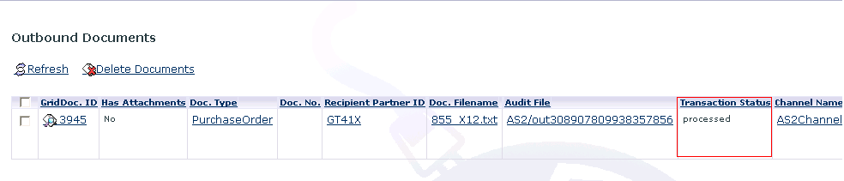

Downloading of Audit file and Receipt Audit File
This enhancement enables the user to download the audit file without searching it in the Audit folder. This will greatly reduce the effort of the user to locate a particular audit file whenever there is a need arise.

The audit file can be accessed from the Inbound and Outbound list view under the Document tab.
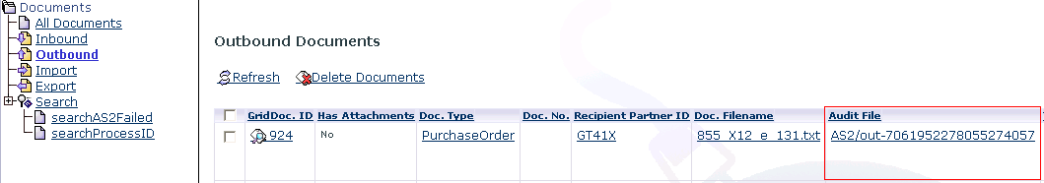

If user needs to access the document corresponding ACK for example AS2 MDN or RNIF Signal, user can go to the Inbound or Outbound Grid Document detail.
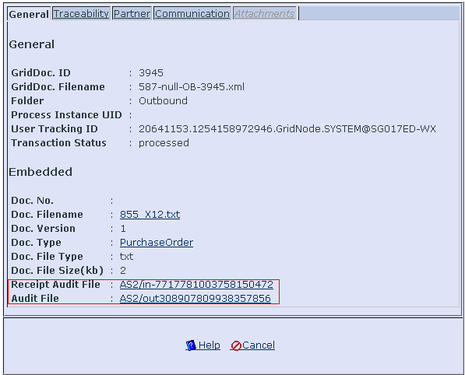

AS2 Doc Type mapping
This enhances the application AS2 capability to extract the document type from the incoming AS2 document content.

Previously, the application can only have one partner function which trigger based on the document type “AS2 Message”. This limits the user to execute the same partner function on the entire incoming message from a particular Trading partner.

By determining the type of the incoming document, user now can apply different partner function on different type of document. For example convert the PO document into an xml document or convert the DesPatch Advice into csv format.

To configure the AS2 Doc type mapping, simply create the following as2 doc type mapping record (Under Mapping Tab) as well as the partner function trigger.

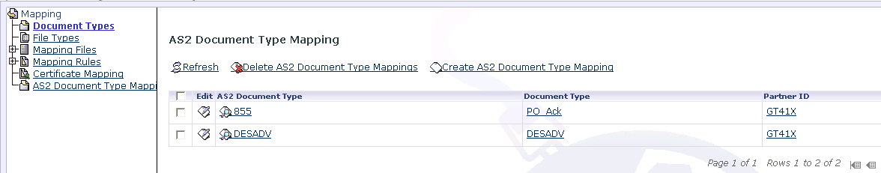

User need to specify the following
- AS2 Document Type: The type of the AS2 message for example 855, DESADV
- Document Type: The internal document type representation of the document in GTAS which is one of the partner function trigger criteria
- Partner ID: The ID of the partner.

It has the similar concept as the RNIF “Business Process Mapping” configuration which map from RNIF document type to the internal document type.

Refer to Chapter 8.5 Managing AS2 Doc Type Mappings under GridTalk 4.2 Administartor Guide for more detail.

Own Document Search Criteria
This enhancement allow the user to specify whether the document search query is visible to all the user in application or only visible to his/her own.

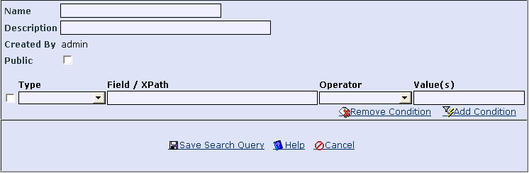

If the user needs to share the search query with other users, check the checked box “Public”. Unchecked the check box otherwise.

Refer to chapter 7.1 Configure search query of GridTalk 4.2 User Guide for detail.

Sorting of the Process Instance Detail page
This enhancement make the sorting of the list of GridDocument under Process Instance Detail page in ascending order. This avoids the confusion on when a particular document is created. For example, given the incoming purchase order request from Trading Partner, the order of the document can be the Inbound 3A4R, Outbound RN ACK, Outbound 3A4C, and follow by Inbound RN ACK.

Certificate Management Changes

Certificate Swapping
This enhancement allows the user to schedule when the swapping from the certificate to the corresponding replacement cert will take place.

Previously the certificate swapping will take place when the cert is expired; however normally Trading Partner will change their cert few days before the expiry date of the certificate.

Prior we configure the time when the cert swapping occur, we need to configure the corresponding replacement certificate.

After that, specify the swap date and swap time.
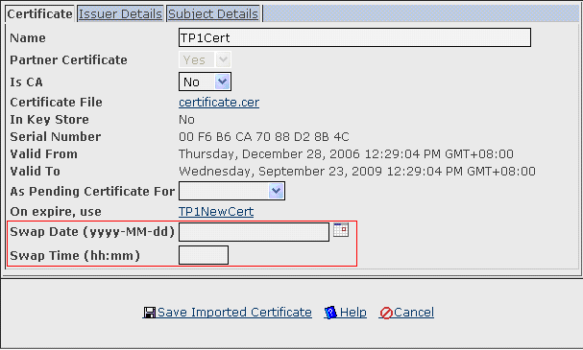

Refer to Chapter 7.7 of GridTalk 4.2 Administration guide for more detail.

V4.2.0 – (Build 4.2.0) – 24 May 2008

Component Upgrades

JBoss Application Server
The JBoss Application Server has been upgraded from v4.0.2 to v4.2.2. This upgrade improves the stability and performance of the application server.

PostgresSQL Database Engine
The database engine has been changed from MYSQL DB to PostgresDB.

Java Run-time Engine (JRE)
The JRE version has been upgraded from v1.5.0_05 to v1.5.0_14. This upgrade improves the performance of the core executing engine of the software.

Changes to Existing Functionalities

Bug Fixes

AS2 Issue

GNDB00028098
In the content of the AS2's MDN, the fields and the values are not separated by a space. Hence, the "<" after the ":" in the document ID was stripped off at receiving partner side and cause unmatched document ID.

The problem is fixed.

RNIF Issue

GNDB00028407
To include in RNIF 2.0 delivery header and service header the following optional fields:

5 0..1 | |-- domain.FreeFormText
Fixed value: DUNS

7 0..1 | |-- locationID.Value
For request, this will be based on Country field in recipient’s BE
For confirmation, this will be based on the 11 0..1 | |-- locationID.Value in the original request. (this is the current implementation)

9 0..1 | |-- domain.FreeFormText
Fixed value: DUNS

11 0..1 | |-- locationID.Value
This will be based on Country field in sender’s BE

12 0..1 | | | | | |-- standardVersion.VersionIdentifier
This will be based on 25 0..1 | | | | | | | |-- standardVersion.VersionIdentifier of the original request.
(Jianyu ‘deliberately’ left out writing out of this tag, not sure the reason behind it, hopefully it’s just an oversight in the implementation, otherwise, may take more time)

43 0..1 | | | | |-- domain.FreeFormText
Fixed Value: DUNS

The problem is fixed.

GNDB00028495
Optional tag domain\freeFormtext under PartnerIdentification of service header shouldn't be hard-coded in service header. We should make it configurable since it is an optional tag.

This is related to the defect fixing GNDB00028407 which hard-coded the domain\freeFormtext under PartnerIdentification.

The problem is fixed.

General Operational Issues

GNDB00028306
The udoc filepath we passed to the batch file has contained the additional forward slash/back slash, which cause the backend handler can't get the udoc successfully.

This is due to the BEAPIHandler add in additional slash at the end of the udoc file path as followed

11 Apr 2007 11:12:36,500 [StreamGobbler] [Thread-16] OUTPUT>K:\jadeprod>DFRUN RNIMPORT C:\GridNode\GridTalk\Export\AP_PO\/PR000074.xml
11 Apr 2007 11:12:45,656 [StreamGobbler] [Thread-15] ERROR>Invalid switch - /pr000074.xml

The problem is fixed.

GNDB00028483
XSLT transformation malfunctions if we extracted the XPATH from the user document more than one time.

Currently, if we extract the user document content via XPATH during the XSLT transformation, the XSLT processor (Apache XALAN version 2.7.0) can only extract the first defined XPATH.

This is due to the path to the user document we passed to the XSLT "Transformer" is not the standard java folder path. We passed in as "c:\test\document" instead of "c:/test/document".

The problem is fixed.

GNDB00028339
After exporting a certificate to keystore, if the same certificate is exported again, GTAS gives a concurrent modification error on the Certificate entity.

The cause of this error is that, the code tries to update the "first" certificate's Is in KS flag to false, followed by updating the "second" certificate's Is In KS flag to true, not considering that the first and second certificates may be the same. After updating the first cert to false, the cert entity's version number is changed. But the second cert was retrieved before that, so when the second cert is being updated, it's version number is out-dated.

The fix should check that if both certificates are the same, there's no need to do the extra updates.

The problem is fixed.

#17
The following Partner function has been impacted by the new features we added in the GT4.1.X. The mapping Rule activity will not be able to be executed successfully.

- Mapping Rule (Header Transformation)
- Exit To Export
- Exit To Port
- Exit Workflow

The problem is fixed.

#26
Currently, the creation of the workflow activity failed if we specify the Mapping Rule “GT’s default header transformation for OB to IB”. This is due to exceeding the length of the “ActivityDescription” field of table “xpdl_activity”.

This is not happening in the MYSQL DB since it just truncated the additional chars that is exceeded the length of the field.

The problem is fixed.

#44
The receiving of the AS2 request message caused the GT4.1.X logic (TXMR) throw exception.

The AS2 receive handler did not set the "tracingID" into the gdoc. Thus, while we firing the TXMR event, the TXMR module will complain there is no "tracingID", and annoying error message is logged in the log file. The "tracingID" need to be set.

The problem is fixed.

User Interface

GNDB00028489
The "Archive Search" tab can't be fully viewed under the screen resolution 1024 * 768.

We moved down the tab "WebServices" and "Archive Search" to the second row to fully unveil the "Archive Search" tab.

The problem is fixed.

Others

GNDB00028457
Currently the logging for the SenderLite is logged to the console. It is needed to be logged in the log file for validating purpose.

GNDB00028341
Currently, the exporting of certificate to trust store require restart of the appserver/tomcat in order for changes to take effect. This behavior is not desired as in production environment it is not viable to restart the server every time a new trusted certificate needs to be added to the trust store.

The problem is fixed.

#1
The format of the Process Instance ID generated by GTAS is “gwf://<RunningNumber>:<Business Activity Identifier>. This format is working fine and is COMPLIANT to the RNIF spec 2.0.

However, one of the customers TP (Broadcom) is not able to handling the same Process Instance ID from different supplier. A few Broadcom supplies are using GTAS, and the Process Instance ID generated can be the same.

According to RNIF, the process instance ID is valid as long as the Process Instance ID generated from the Process Initiator (The Broadcom supplier) is unique between the parties involving in RNIF transaction. Meaning the process instance ID generated by the Process Initiator is not need to be unique across the world

GTAS is based on the RNIF to generate the Process Instance ID. This is the limitation in the Broadcom server

To resolve the issue, we added in the additional field that is the GRIDNODE ID in the Process Instance as follow

gwf://123:2200/Notify of Invoice where 2200 is the Gridnode ID

To enable the above features, modify the configuration file “bpssKey.properties” under “data\GNapps\gtas\data\sys\workflow\bpssKey” by adding in the particular Partner ID that contain the same limitation as Broadcom as follow.

<PartnerID>.include.Gridnode.ID

The problem is fixed

#12
GTAS will perform the extraction of the user document element during the folder transistion. However, if the user documents itself is an invalid XML document, no alert notification will be triggered to notify the invalid content of the user document.

This enhancement cater for the case when GT performing "doExist" folder transistion (Both Import, Inbound) and raise alert if problem in extracting the user document element.

The problem is fixed.

#46
Improve the housekeep logic to delete the system temp dir (The temp dir use by GTAS is no longer the location of the temp dir defined by the OS. It will be stored under the GTAS installation folder) and the delete of nested folder

The nested folder under the temp folder has been improved so that they will be deleted as well

The problem is fixed.

Enhancements

Alert Notification Changes

Added in new AS2 alert notification
Currently, there is no alert notification when the partner has received the AS2 request message and when the AS2 request message has reached maximum retries.

This enhancement includes the notification of the mentioned scenario.

To enable the alert when the TP has received the request message,
The steps for the configuration are same for the RNIF.

To enable the alert when we reached maximum retries for the AS2 request message,
- Configure a level 4 alert trigger with the appropriate Doc Type, and Partner
- Specify the recipient in the alert trigger
- Add dynamic recipient in the Alert template "DOCUMENT_RESEND_EXHAUSTED"
The above configuration is just served as a reference. We don’t really need to configure the alert trigger as Level 4 trigger.

Process Changes

RNIF Compression
The size of the payload for some PIP for example 7C7 is relatively huge and the network bandwidth we need to transfer the message is higher.

Based on the RNIF technical advisor, we include the RNIF compression feature into the application. It basically compresses the service content and the attachment if there exists. The compression is done individually on the service content and attachment.

If we received the compressed RN payload, the payload will be automatically decompressed. No configuration is needed to enable such a decompress process.

To enable the RNIF compression, we just need to tick the Compression option under the Process Def → Process Action configuration page as followed.

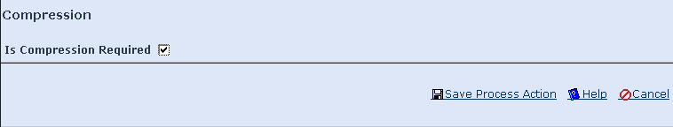

Configuration/Log files Directory

Update of folder hierarchy
The following folder structure has been updated

1) Log folder
2) Configuration files folder and transaction document folder
3) Temp folder

1) Log folder
Currently all the log files (gts.log, server.log, httpreceiver.log) are scattered in different location. The enhancement has moved all the log files into a centralized folder which make the retrieval of the log file for troubleshooting more convenient.

The centralized folder is under %GRIDTALK_HOME%\logs.

2) Configuration files folder and transaction document folder
To enable the GTAS clustering, the configuration files (schema, dtd files etc) and the transaction document (audit files, user document, grid document) should be put under a shared folder which is accessible from different nodes in the cluster.

The centralized folder is under %GRIDTALK_HOME%\data\GNapps\

Note: The clustering features are not enabling in the GT4.2 yet.

3) Temp folder
Currently, the temp files generated by the GTAS are being stored under the OS default temp files directory. This result the number of files in the temp folder becomes unmanageable when more and more transaction document was being processed by GTAS.

The temp files should be stored under the GTAS installation directory so that we can manage the temp files easily for example by running the housekeeping without worrying we may delete temp files generated by other application other than those generated by GTAS.

Known Issues

Functional Issues

Operational Issues

Export of document without file extension
The Export function will not work under the following scenarios:

Scenario 1:
- The destination export directory of the user document or attachments already contains a folder with the same name as user document or attachments.

Scenario 2:
- The user document does not contain file extension – this refers to two possible scenarios:
- the user document itself not containing a file extension
- the Different Filename option is chosen and the Filename specified does not contain a file extension
- There are attachments to export – this refers to two possible scenarios:
- The document itself have attachments when it’s received or imported
- The Export GDoc option is chosen
- The Group Attachments Only option is chosen for the File Grouping field

This is due to the fact that operating systems do not allow a file and a directory of the same name, in this case, the file refers to the user document and the directory refers to the attachment directory that is named after the user document filename (without file extension).

Communication Issues
N/A

Document Issues
N/A

Non-Functional Issues
N/A

Release Packs

Installation Packs

Build 4.2.1

Installation on Windows

Executable

Package Filename: GridTalk4.2.1_jBoss_win.exe

- Double-click on the file to start the installation
- Follow through the instructions on screen to install.
- There will be two application shortcuts created in Program Files for you to start and shutdown the GridTalk application.

Install as Windows Service
- Remove all existing GridTalk Windows Services from the Control Panel\Administrative Tools\Services console. These may include “jBoss” and “mySQL” from V2.4 series, and “GridTalk_AS”, “GridTalk_DB”, and “GridTalk_Logger” from V4.0 series.
- If GridTalk application is running, shut it down using the shutdown.bat located at GRIDTALK_HOME\bin directory.
- Double-click the service.bat located at GRIDTALK_HOME\bin\admin directory.
- Type I when asked whether to install or remove services.
- This will install the GridTalk application as Windows Service and start the application at the same time

Installation on Solaris

Zip Installation
Package Name: GridTalk4.2.1_jBoss_solarisX86_full.zip

- Create user account “gridtalk”

- Unzip the package to the install directory (EG. /home/gridtalk/)
unzip GridTalk4.2.1_jBoss_solarisX86_full.zip –d .

- Set environment variable $GRIDTALK_HOME by modifying “.bash_profile”
GRIDTALK_HOME=/home/gridtalk/
export GRIDTALK_HOME

- Set permission 700 for the folder $GRIDTALK_HOME/db
chmod 700 $GRIDTALK_HOME/db

- Modify the permission for executable file
chmod +x ./jakarta-ant-1.5.1-bin/bin/ant

chmod +x $GRIDTALK_HOME/bin/*.sh
chmod +x $GRIDTALK_HOME/bin/admin/*.sh
chmod +x $GRIDTALK_HOME/jboss-4.2.2.GA/bin/*.sh
chmod +x $GRIDTALK_HOME/jre150_20/bin/java
chmod +x $GRIDTALK_HOME/pgsql/bin/*

- Startup the GT application
- Shutdown the GT application
- Disable the JBOSS MQ to auto generate the JMS related DB table
$GRIDTALK_HOME/jboss-4.2.2.GA/server/default/deploy/jms/Postgres-jdbc2-service.xml
$GRIDTALK_HOME/jboss-4.2.2.GA/server/default/deploy/jms/Postgres-jdbc-state-service.xml

Locate the statement below
CREATE_TABLES_ON_STARTUP = TRUE

And update it to the following by changing the flag from ‘TRUE’ to ‘FALSE’
CREATE_TABLES_ON_STARTUP = FALSE

Build 4.2.2

Installation on Solaris
Pre-requisite: Install GT4.2.1 Solaris release

Patch installation

Package filename: GridTalk4.2.1_jBoss_solarisX86_patch4.2.2.zip

- Unzip the patch in temp directory
unzip GridTalk4.2.1_jBoss_solarisX86_patch4.2.2.zip -d patch

- Change the permission
cd patch
chmod +x *.sh

- Run the patch
Run the following if we are patching main node in the cluster or we are patching in the non-cluster environment.
# run the following if the node is the first node in the cluster/Or non-cluster environment
./patch.sh –data

Run the following if we are in the cluster environment and we are patching the child nodes in the cluster.
# run the following if the node is not the first node in the cluster.
./patch.sh

Build 4.2.3

Installation on Fedora 8

Zip installation

Package Name: GridTalk4.2.3_jBoss_fedoraX86_noDB.zip

- Unzip the package to the install directory (EG. /home/gridtalk/)
unzip GridTalk4.2.3_jBoss_fedoraX86_noDB.zip –d .

- Set environment variable $GRIDTALK_HOME by modifying “.bash_profile”
GRIDTALK_HOME=/home/gridtalk/
export GRIDTALK_HOME

- Modify the permission for executable file
chmod +x ./jakarta-ant-1.5.1-bin/bin/ant

chmod +x $GRIDTALK_HOME/bin/*.sh
chmod +x $GRIDTALK_HOME/bin/admin/*.sh
chmod +x $GRIDTALK_HOME/jboss-4.2.3.GA/bin/*.sh
chmod +x $GRIDTALK_HOME/jre150_20/bin/java
chmod +x $GRIDTALK_HOME/pgsql/bin/*

- Startup the GT application
- Shutdown the GT application
- Disable the JBOSS MQ to auto generate the JMS related DB table
$GRIDTALK_HOME/jboss-4.2.3.GA/server/default/deploy/jms/Postgres-jdbc2-service.xml
$GRIDTALK_HOME/jboss-4.2.3.GA/server/default/deploy/jms/Postgres-jdbc-state-service.xml

Locate the statement below
CREATE_TABLES_ON_STARTUP = TRUE

And update it to the following by changing the flag from ‘TRUE’ to ‘FALSE’
CREATE_TABLES_ON_STARTUP = FALSE

Installation on Windows
Refer to section 3.1.2 Windows Zip Installation of GridTalk 4.2 Installation Guide (Windows).doc.

Build 4.2.4

Installation on Windows

Zip Installation
Refer to section 3.1.2 Windows Zip Installation of GridTalk 4.2 Installation Guide (Windows).doc.

Upgrade Packs

Build 4.0.2 – 4.2.0
Not supported. It needs to be fresh installation for now.

Patches
Not available.

